SPRING CREEK WATERSHED COMMISSION
HYBRID REGULAR MEETING
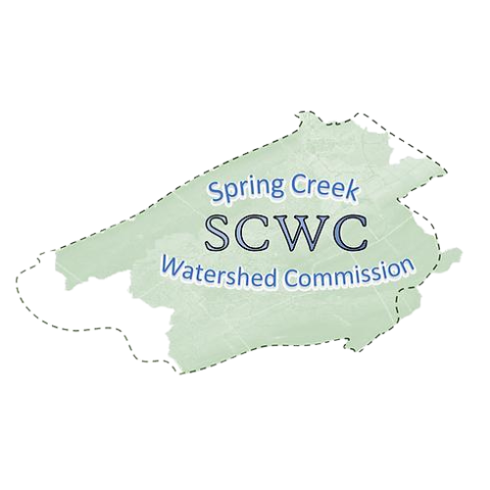
Wednesday, September 18, 2024
7:00 PM to 8:30 pm
College Township Municipal Building
(2nd Floor Council Room)
1481 E. College Avenue
State College PA. 16801

Zoom Link:
https://us06web.zoom.us/j/89272152245?pwd=fUevNZ5Tg0y0frnPbDx2A74ffIyG7j.1
Meeting ID: 892 7215 2245
Passcode: 117650

- Call To Order: Chair Brachbill will call the meeting to order.
- Welcome and Roll Call: recognize representatives present
- Public Comment & Written Correspondence: The public is invited to address the Commission
- Approval of Minutes of July 17th, 2024, Meeting Minutes
https://docs.google.com/document/d/1QVur3itMQFgLxJe9TdM-y9g507svcflQ/edit?usp=sharing&ouid=103973787035446491328&rtpof=true&sd=true
- Educational Topic: Introduction by Jasmine Fields
Presenter: Richard Novak
Topic: Update on the endangered species list.
- Report of Officers and Committees:
- Financial Report & Approval of Bills – Kevin Abbey (Treasurer)
September 2024 Update:
https://docs.google.com/document/d/19xBUiYildIBUjtFDsRKaCOx7fAz1e_vC/edit?usp=sharing&ouid=103973787035446491328&rtpof=true&sd=true
- 2025 Budget Review/Adoption
- Coordinating Committees Update– Bob Igo (Vice Chair)
- Education Update – Jasmine Fields (Member At Large)
- AmeriCorps Update– Elyse Johnson and Caitlin Dooley
- ATLAS Committee Update - Jon Eaton (Atlas Chair)
- Old Business:
  - Municipal Authorities Donation requests.
  - SCWC partnership with Trout Unlimited for November 2024 Redd Count (Date TBD)
  - MS4 Partners meeting - July 18 discussed Pollution Reduction Projects, sharing costs/credits. Kent Baker attended for SCWC
- New Business:
  - Stormwater Educational Series - Elyse Johnson
  - Mike Tylka, CRPA Planning director, is seeking public input on their comprehensive plan until October 1st: https://cp2045-centrecog.hub.arcgis.com/
  - Todd Dolbin - CBICC is discussing a strategic plan and shared their vision for economic growth with SCWC
- Around the Watershed, water-related news/projects from
member municipalities
- Matters of Records: The last SCWC Member Meeting of 2024 will be Wednesday, November 20, 2024 – Location TBD.
Upcoming committee meetings:
  - SCWC Executive Meeting will be held on October 16, 2024, at Camp Breac in person/via TEAMS, 11:30am to 1pm.
  - SCWC Government Committee Meeting October 17, 2024, 11AM-12PM in College Township Council Room and via Zoom
  - SCWC Atlas Committee Thursday, September 19, 1-3PM in Patton Township’s Board Room/via Zoom
  - SCWC Conservation & Stewardship Committee, November 7th from 1-2:30 PM
Adjournment

